

Year 10 Science 2019 Name: _______________________

**Biology 2 Test: Evolution and Natural Selection**

**SECTION 1: MULTIPLE CHOICE** (1 mark each)

Circle your answer in the section below:

1. A B C D 6. A B C D
2. A B C D 7. A B C D
3. A B C D 8. A B C D
4. A B C D 9. A B C D
5. A B C D 10. A B C D
6. Which of these is an example of a structural adaptation?
   1. A dog pants when it gets hot.
   2. Camels can store fat and their bodies are very good at conserving water.
   3. Cactus plants have sharp spines to stop animals from eating them.
   4. Bats hunt during the evening, when there are most insects about.
7. Desert hopping mice dig burrows and sleep in them during the day to escape the heat. When it gets cold they snuggle together to keep warm, but when it gets hot, they spread themselves out. This is an example of
   1. a physiological adaptation.
   2. a functional adaptation.
   3. a structural adaptation.
   4. a behavioural adaptation.
8. Which of the following is not an example of natural selection?
   1. Cheetahs have evolved to be faster as their prey has become faster.
   2. Giraffes have evolved longer necks to reach more food.
   3. Sheep are being bred to have finer wool.
   4. In nature, albino animals are rare as they are easier for predators to catch.
9. Natural selection only occurs when
   1. there is sexual reproduction.
   2. there are more offspring produced than will survive to breed.
   3. there is change in the environment.
   4. humans influence the environment.
10. Darwin’s Theory of Evolution says that
    1. living things change gradually over generations as they adapt to their changing environment.
    2. living things change suddenly in response to sudden changes in their environment.
    3. living things change themselves when they see the need to.
    4. living things change because of mutations.
11. All things being different between and within species is called
    1. similarity
    2. speciation
    3. evolution
    4. diversity
12. Which of the following is not necessary for evolution?
    1. variation
    2. competition
    3. natural selection
    4. meiosis
13. Which of the following evidence for evolution would not be used to determine how closely related two species are?
    1. features which are not similar in structure but perform the same function in unrelated species, eg insect wings and bat wings
    2. similar structures which perform different functions in related species, eg dual bone in forearm of human, frog and pigeon
    3. structures which are found in related species, but which may no longer serve a function, eg whale pelvis
    4. fossils which show gradual change in similar species
14. Which of the following statements about Natural Selection is true?
    1. Natural Selection is based on the idea that life is an ongoing struggle for survival.
    2. Organisms do not need to compete for food, water, mates, light or space.
    3. Organisms compete for natural resources only with other members of the same species.
    4. Those individuals who compete successfully have less chance of passing on their genes.
15. Use the phylogenetic tree below to determine which species are most closely related?
    1. Human and mouse
    2. Platypus and Tammar wallaby
    3. Zebra finch and lizard
    4. Pufferfish and Elephant shark

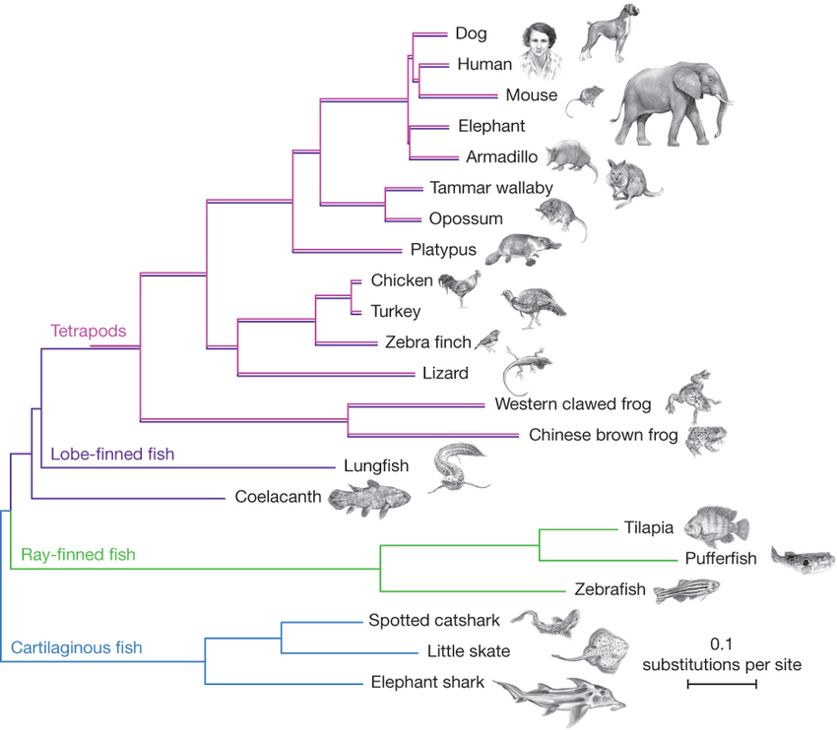

**SECTION 2: WRITTEN**

**Write your answers in the spaces provided.**

1. A zoologist found an unfamiliar lizard on a remote island off the coast of Western Australia. It is similar to a mainland species which has previously been identified, but the zoologist is not sure if it the same species or not. What is a species and how could the zoologist confirm whether the new lizard is the same or different species to the mainland lizards? (2 marks)

_______________________________________________________________________

_______________________________________________________________________

_______________________________________________________________________

_______________________________________________________________________

_______________________________________________________________________

1. Natural selection relies on selective agents, which may or may not act by killing the less suited individuals.
   1. Give one example of a selective agent that does kill the ‘poorly adapted’ or ‘less fit’ individuals. (1 mark)

________________________________________________________________

________________________________________________________________

* 1. Give one example of a selective agent that does not act by killing. (1 mark)

________________________________________________________________

________________________________________________________________

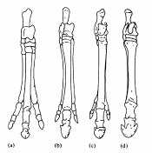

1. It is thought that modern horses with hooves evolved from ancient horses with three toes.
   1. What type of evidence for evolution does this assumption rely on?

___________________________________________

___________________________________________

___________________________________ (2 marks)

* 1. List and briefly describe the processes that would have resulted in this change over time.

________________________________________________________________

________________________________________________________________

________________________________________________________ (3marks)

1. Scorpionflies (Mecoptera) and true flies (Diptera) have enough similarities that entomologists (scientists who study insects) consider them to be closely related. Scorpionflies have four wings of about the same size, and true flies have a large front pair of wings but the back pair is replaced by small club-shaped structures.

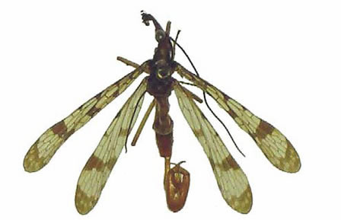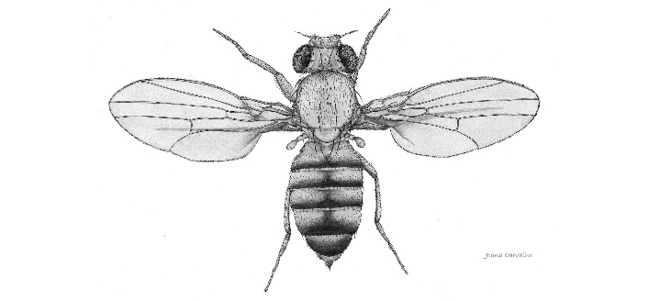

*Mecoptera Diptera*

* 1. Name this type of evidence for evolution.

________________________________________________________ (1 mark)

* 1. Briefly describe one other way that scientists could support their idea that these species have evolved from common ancestors?

_______________________________________________________________________________

_______________________________________________________________________________

_______________________________________________________________________________

_______________________________________________________________________________

_______________________________________________________________________________

(2 marks)

1. 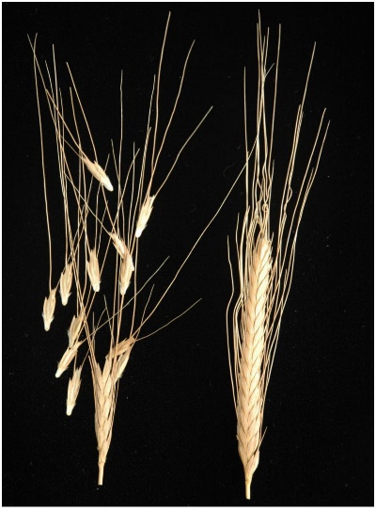Wild and ancient wheat varieties have shattering stalks that cause the grain to break off from the stalks while still green. Domesticated modern wheat varieties have non-shattering stalks that hold the grain together, even after the grain has ripened and dried. This allows the grain to be more easily harvested, as it does not fall to the ground.
   1. What type of adaptation is this?

_________________________________ (1 mark)

* 1. Is this an example of natural or artificial selection?

_________________________________ (1 mark)

* 1. Where did this non-shattering gene come from?

_________________________________________________________ (1 mark)

* 1. What do you think would happen to the wild wheat population if domestic wheat was released into the wild?

_________________________________________________________________

_________________________________________________________________

_________________________________________________________________

(1 marks)

1. Explain how embryology is used to support the theory of evolution. Diagrams and examples may be useful.

______________________________________________________________________

______________________________________________________________________

______________________________________________________________________

______________________________________________________________________

(4 marks)

**END OF TEST (OUT OF 30 MARKS)**